

College of Information and Computing Sciences

E-COMMERS WEBSITE
Software Requirement Specification

Information Technology Project 2025

Submitted by:

GERRON TIPONES
DYHAN CABRERA

Submitted to:

ALBERT CANLAS

Date of submission
AUG 14 2025

Table of Contents
Table of Contents ii
Revision History ii
1. Introduction 1
1.1 Purpose 1
1.2 Document Conventions 2
1.3 Intended Audience and Reading Suggestions 2
1.4 Product Scope 2
1.5 References 3
2. Overall Description 4
2.1 Product Perspective 4
2.2 Product Functions 4
2.3 User Classes and Characteristics 8
2.4 Operating Environment 9
2.5 Design and Implementation Constraints 10
2.6 Project Documentation 10
2.7 User Documentation 10
2.8 Assumptions and Dependencies 10
3. External Interface Requirements 11
3.1 User Interfaces 11
3.2 Hardware Interfaces 14
3.3 Software Interfaces 14
3.4 Communications Interfaces 14
4. System Features 15
4.1 E-R Diagram 15
4.2 Use Case Diagram 16
4.3 Use Case Scenarios 17
4.5 Activity Diagrams 23
5. Other Nonfunctional Requirements 31
5.2 Performance Requirements 31
5.3 Safety Requirements 31
5.4 Security Requirements 31
5.5 Software Quality Attributes 32
5.6 Business Rules 33
6. Other Requirements 34
Appendix A: Glossary 34

Revision History
Name | Date | Reason For Changes | Version
 | 8/14/25 |  | 1.0

1. Introduction

1.1 Purpose
This document defines the functional and non-functional requirements for the E-commerce Website, enabling customers to browse products, add items to cart, make secure purchases, and track orders.

1.2 Document Conventions
All requirements labeled as "REQ-" are mandatory. Use case names follow the format UC-Name. Diagrams follow UML 2.0 conventions.

1.3 Intended Audience and Reading Suggestions
Developers: Focus on Sections 3, 4, and 5.
Testers: Review functional requirements and use cases in Section 4.
Project Managers: Pay attention to constraints, assumptions, and dependencies.

1.4 Product Scope
The E-commerce Website allows users to browse and purchase products online, manage their accounts, and make secure payments.

1.5 References
IEEE Std 830-1998: Recommended Practice for Software Requirements Specifications
E-commerce Security Standards 2025

2. Overall Description

2.1 Product Perspective
The E-commerce Website will be an online platform that connects sellers with buyers and provides secure payment integration.

2.2 Product Functions
1. Product Browsing and Search
2. Shopping Cart Management
3. Order Placement
4. Secure Payment Processing
5. Order Tracking
6. Admin Product Management

4.1 E-R Diagram

4.2 Use Case Diagram

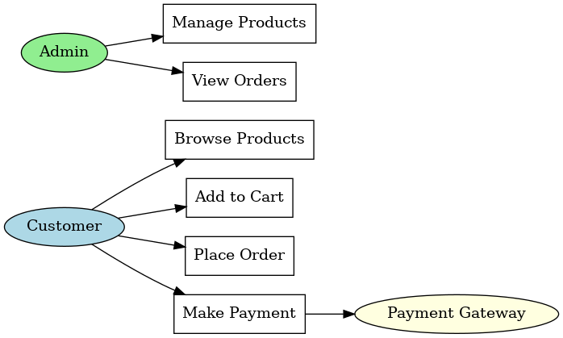

4.5 Activity Diagram - Place Order

